Open Doors to History
Story and photos by John J.N. Chalmers
While most of the 30-plus sites included in the Historic Festival and Open Doors 2024 program were located in Edmonton, the span of the program reached from the grain elevator in Leduc, to the Pioneer Museum in Westlock, to participation in activities at the Métis Crossing near Smoky Lake and to walking tours of historic areas in our city.
Held from July 7-14, the 2024 Festival highlighted Innovation, which was clearly evident among the aircraft at the Alberta Aviation Museum, where CTV Edmonton came on June 27 to record promotional spots that were aired on July 4 during the station’s morning show to advertise the Festival. Here’s a sampling of this year’s Festival locations. Links to the sites are shown in blue text, accessible through the edition of this newsletter received by e-mail.
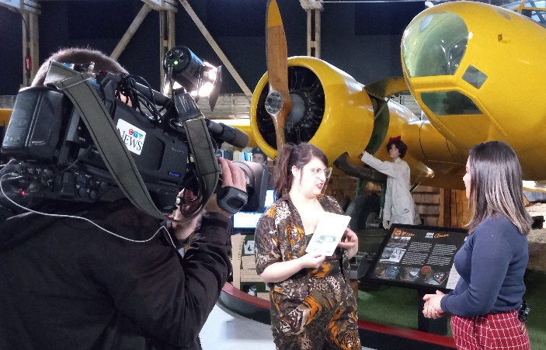
At left, cameraman Bruce of CTV Edmonton focuses on EDHS president Kelsey Kendrick being interviewed by Kimberly Wynn in one of four promo spots shot at the Alberta Aviation Museum to promote the Historic Festival and Open Doors activity. At right is one of the ads shown during the CTV morning show. The annual event provides a special time for visitors to see locations they might not know or visit, often with tour guides on site or opportunity to take a self-directed tour. Many of the locations listed in the schedule can be visited all year long.
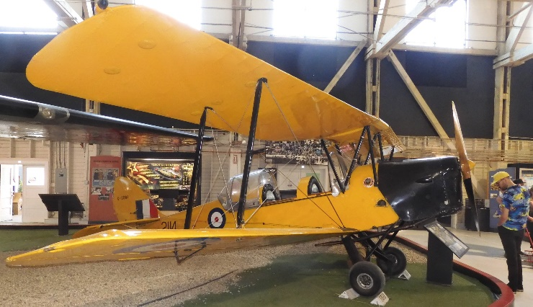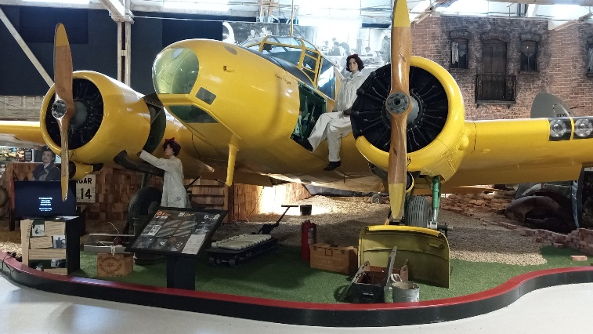
The two aircraft shown here at the Alberta Aviation Museum on Kingsway played an important role in Edmonton’s wartime history. At left is a de Havilland Tiger Moth, used for training pilots at No. 16 Elementary Flying Training School. At right is an Avro Anson, used for training navigators at No. 2 Air Observer School, and for providing multi-engine experience for pilots. Both schools were part of the British Commonwealth Air Training Plan and these aircraft were types flown during the Second World War from the hangar that is now home to the Museum.
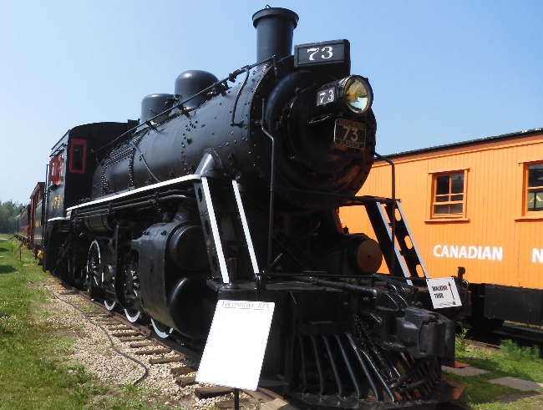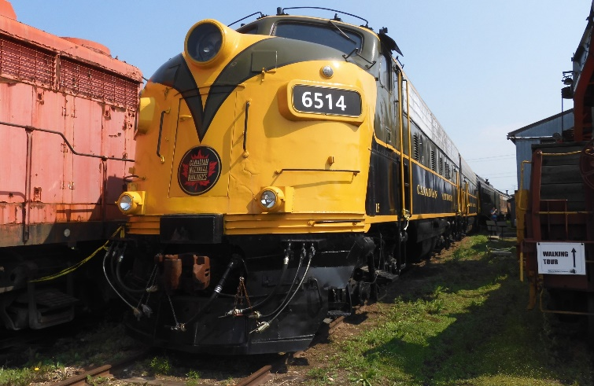
At the Alberta Railway Museum in northeast Edmonton, open only on summer weekends, both a vintage steam-powered locomotive and a newer diesel-powered engine are displayed among the many railway cars and engines in the collection. Historic buildings such as a water tower and the 1909 original train station from St. Albert are among the buildings and railway cars that visitors can visit on a self-guided walking tour. Rides are available on a speeder and visitors can walk through many of the cars such as a mail car, passenger car, freight cars and a caboose.
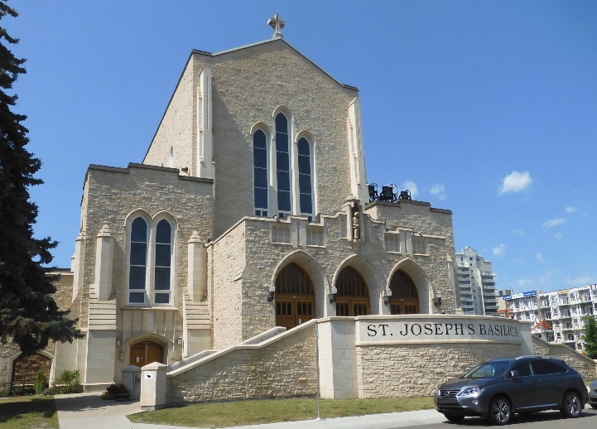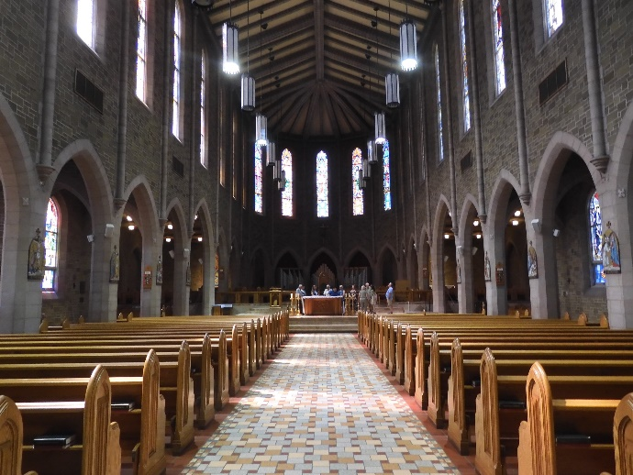
St. Joseph’s Basilica at the corner of Jasper Avenue and 113 Street, can seat 800 people in its cavernous sanctuary. Among the features of the basilica are 69 beautiful stained glass windows and the Casavant organ has 3,150 pipes. The magnificent building, which is the cathedral church of the Catholic Archdiocese of Edmonton, began with the construction of its basement in 1925. It was used as a church until construction of the superstructure began in the 1960s with completion in 1963 and consecration of the new building on May 1 of that year.
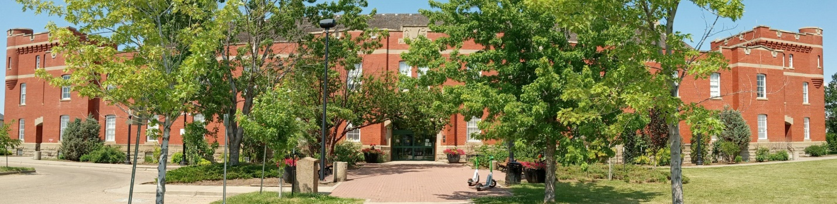
Located on 108 Avenue and 104 Street, the impressive Prince of Wales Armouries brick building was completed in 1915, accommodated various groups and organizations for nearly 70 years and was transferred to the City of Edmonton in 1982. Today it is the home of City of Edmonton Archives and the Loyal Edmonton Regiment Military Museum, both of which were on the Historic Festival and Open Doors 2024 visiting schedule.
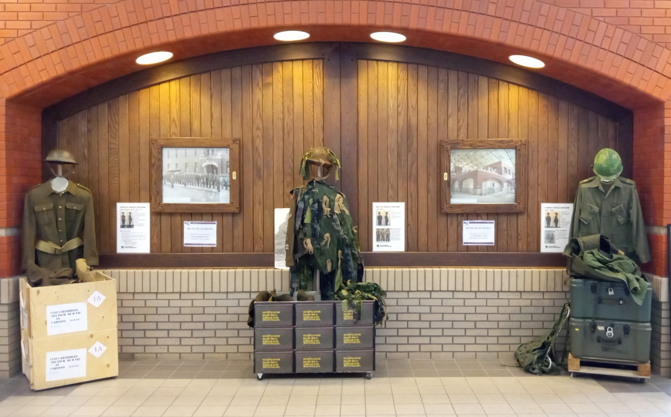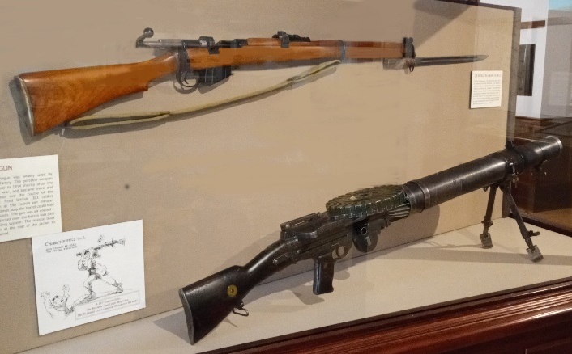
Upon entering the Armouries building, seen immediately are army uniforms among the several displayed in the main hallway. At right in the Loyal Edmonton Regiment Military Museum are two of the weapons used by Canadian military forces. Above is the famous Lee-Enfield .303 calibre rifle used for many years. Below is a Lewis machine gun, used in the First World War by army forces on the ground and by fighter airplanes flying in battle.
Included in this year’s Festival are two distinctly different gardens. One garden is full of vegetables and flowers, while the other has none, but is a garden of cultural history that provides a place for peace and contemplation.
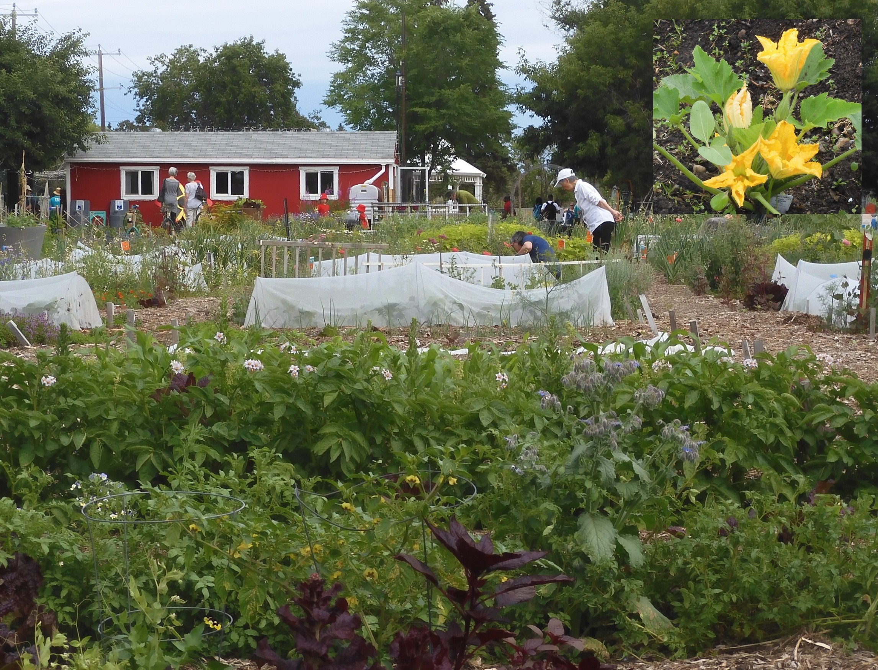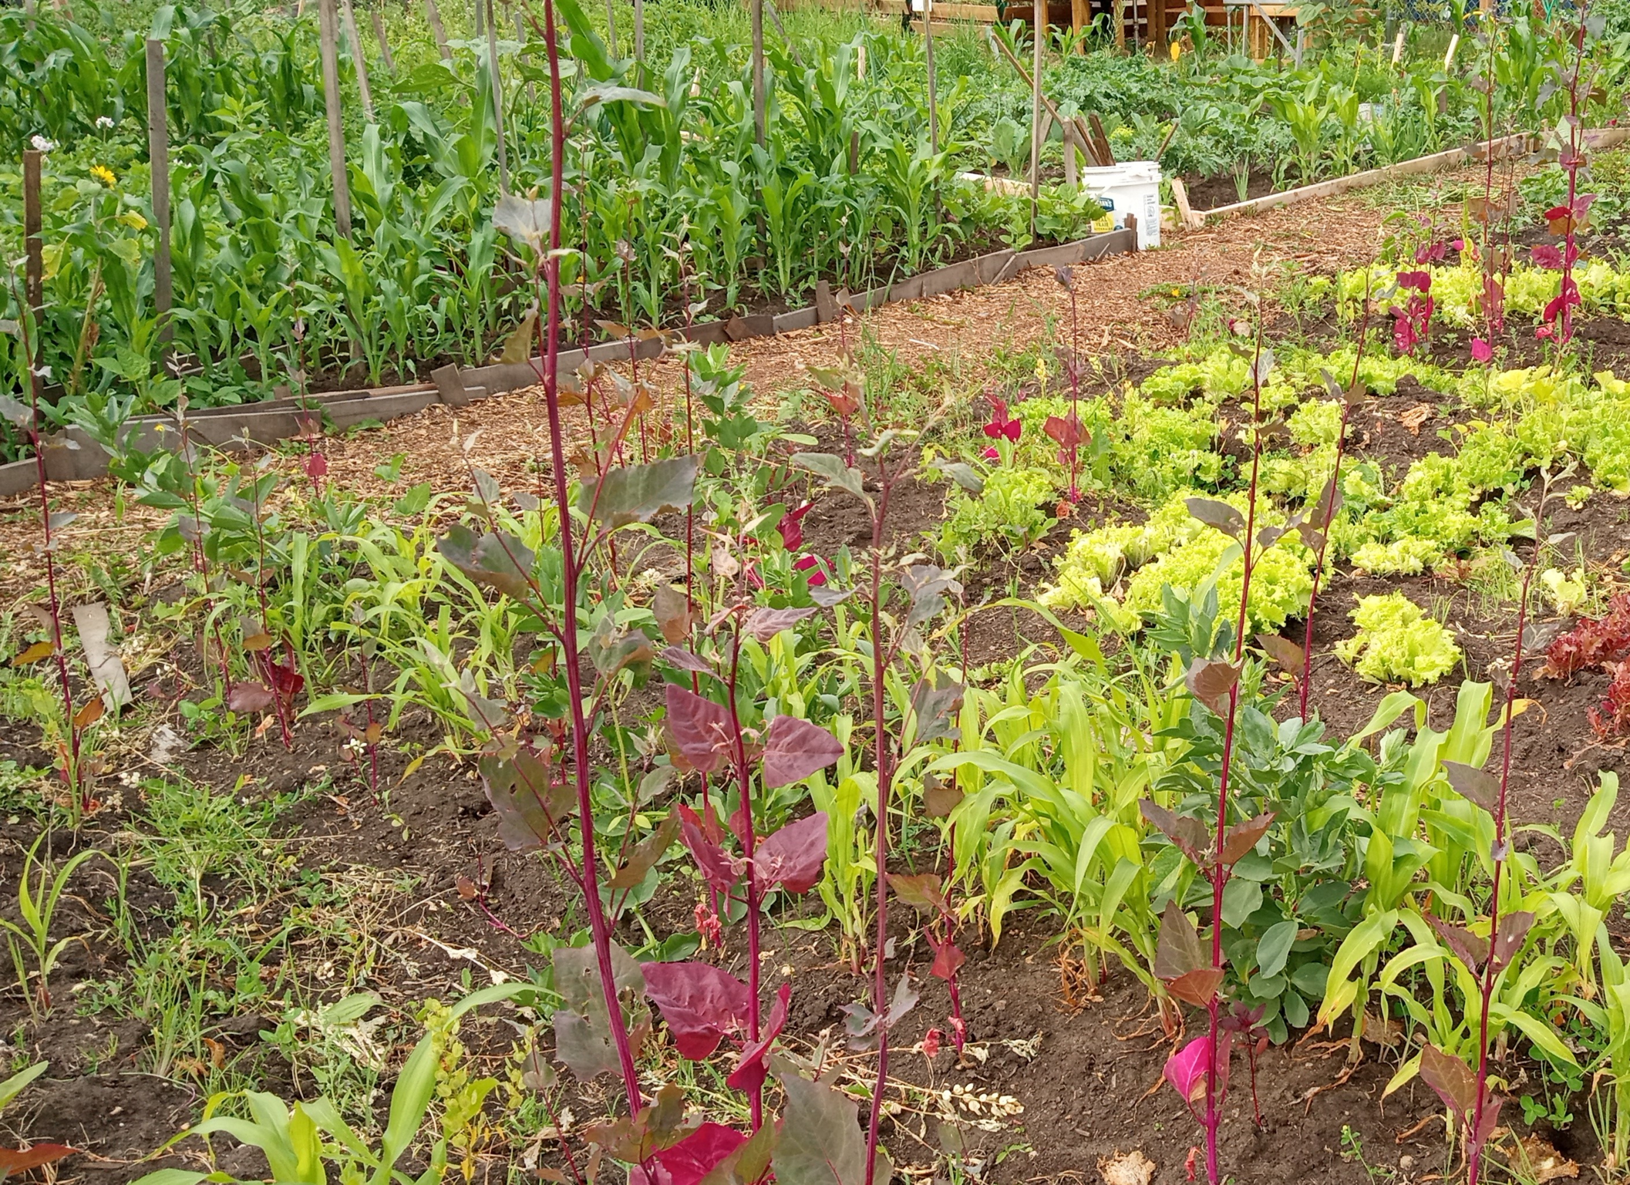
The Edmonton Urban Farm at 79 Street and 113 Avenue is a project of Explore Edmonton, and is comprised of garden plots planted by 22 community groups, providing fresh food for 300 people involved in tending their crops. At left is an overview of an area with the inset of edible zucchini blossoms, showing that even veggies can have beautiful flowers! In the two-acre City-owned property are potatoes, tomatoes, carrots, cabbages, beets, corn, kale, lettuce, cabbage, onions and unfamiliar plants! Thousands of school students visit each year to learn how things grow!
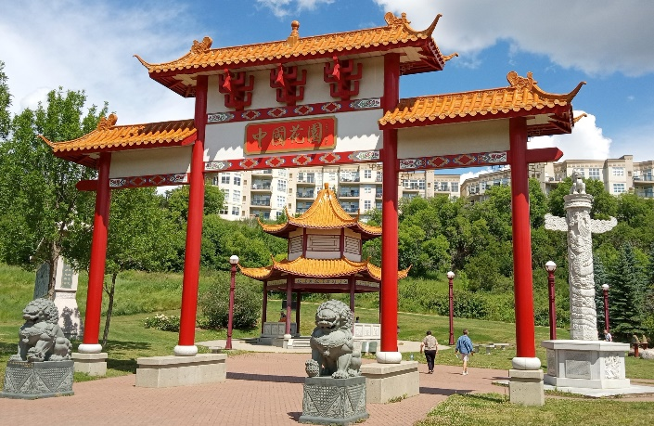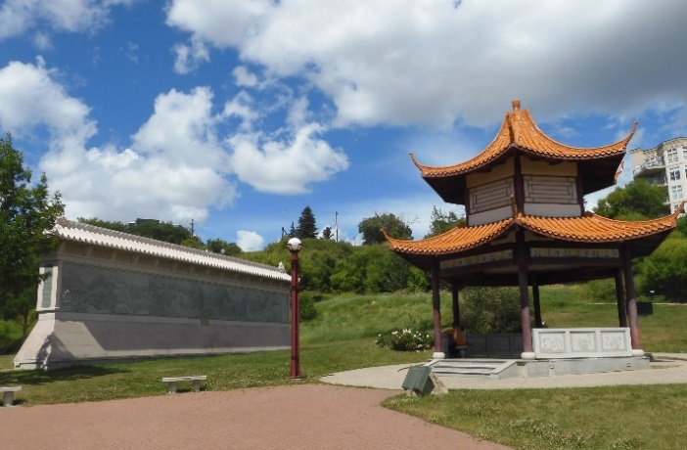
At the Chinese Garden, located on Grierson Hill Road in Louise McKinney Park, visitors enter through the Friendship Gate, with its two stone lion sculptures serving as guardians. At right can be seen the large Nine Dragon Wall at left, resembling the Great Wall of China and symbolizing protection that it provides. The hexagonal Main Pavilion commemorates Chinese pioneers. Also at the garden is a stone bridge, rocks carved with images of the zodiac figures aligned with the Chinese calendar years and a carved stone pillar, reminiscent of a totem pole, that faces Beijing. Features of the garden were made in China, shipped in components to Edmonton and reassembled at the park.
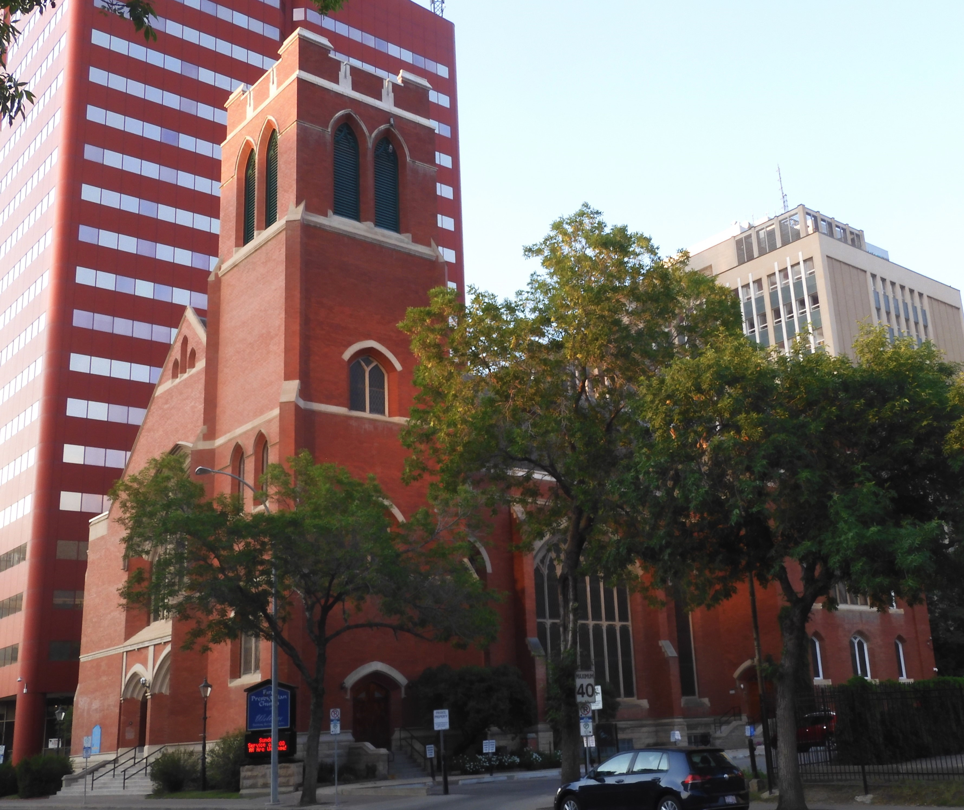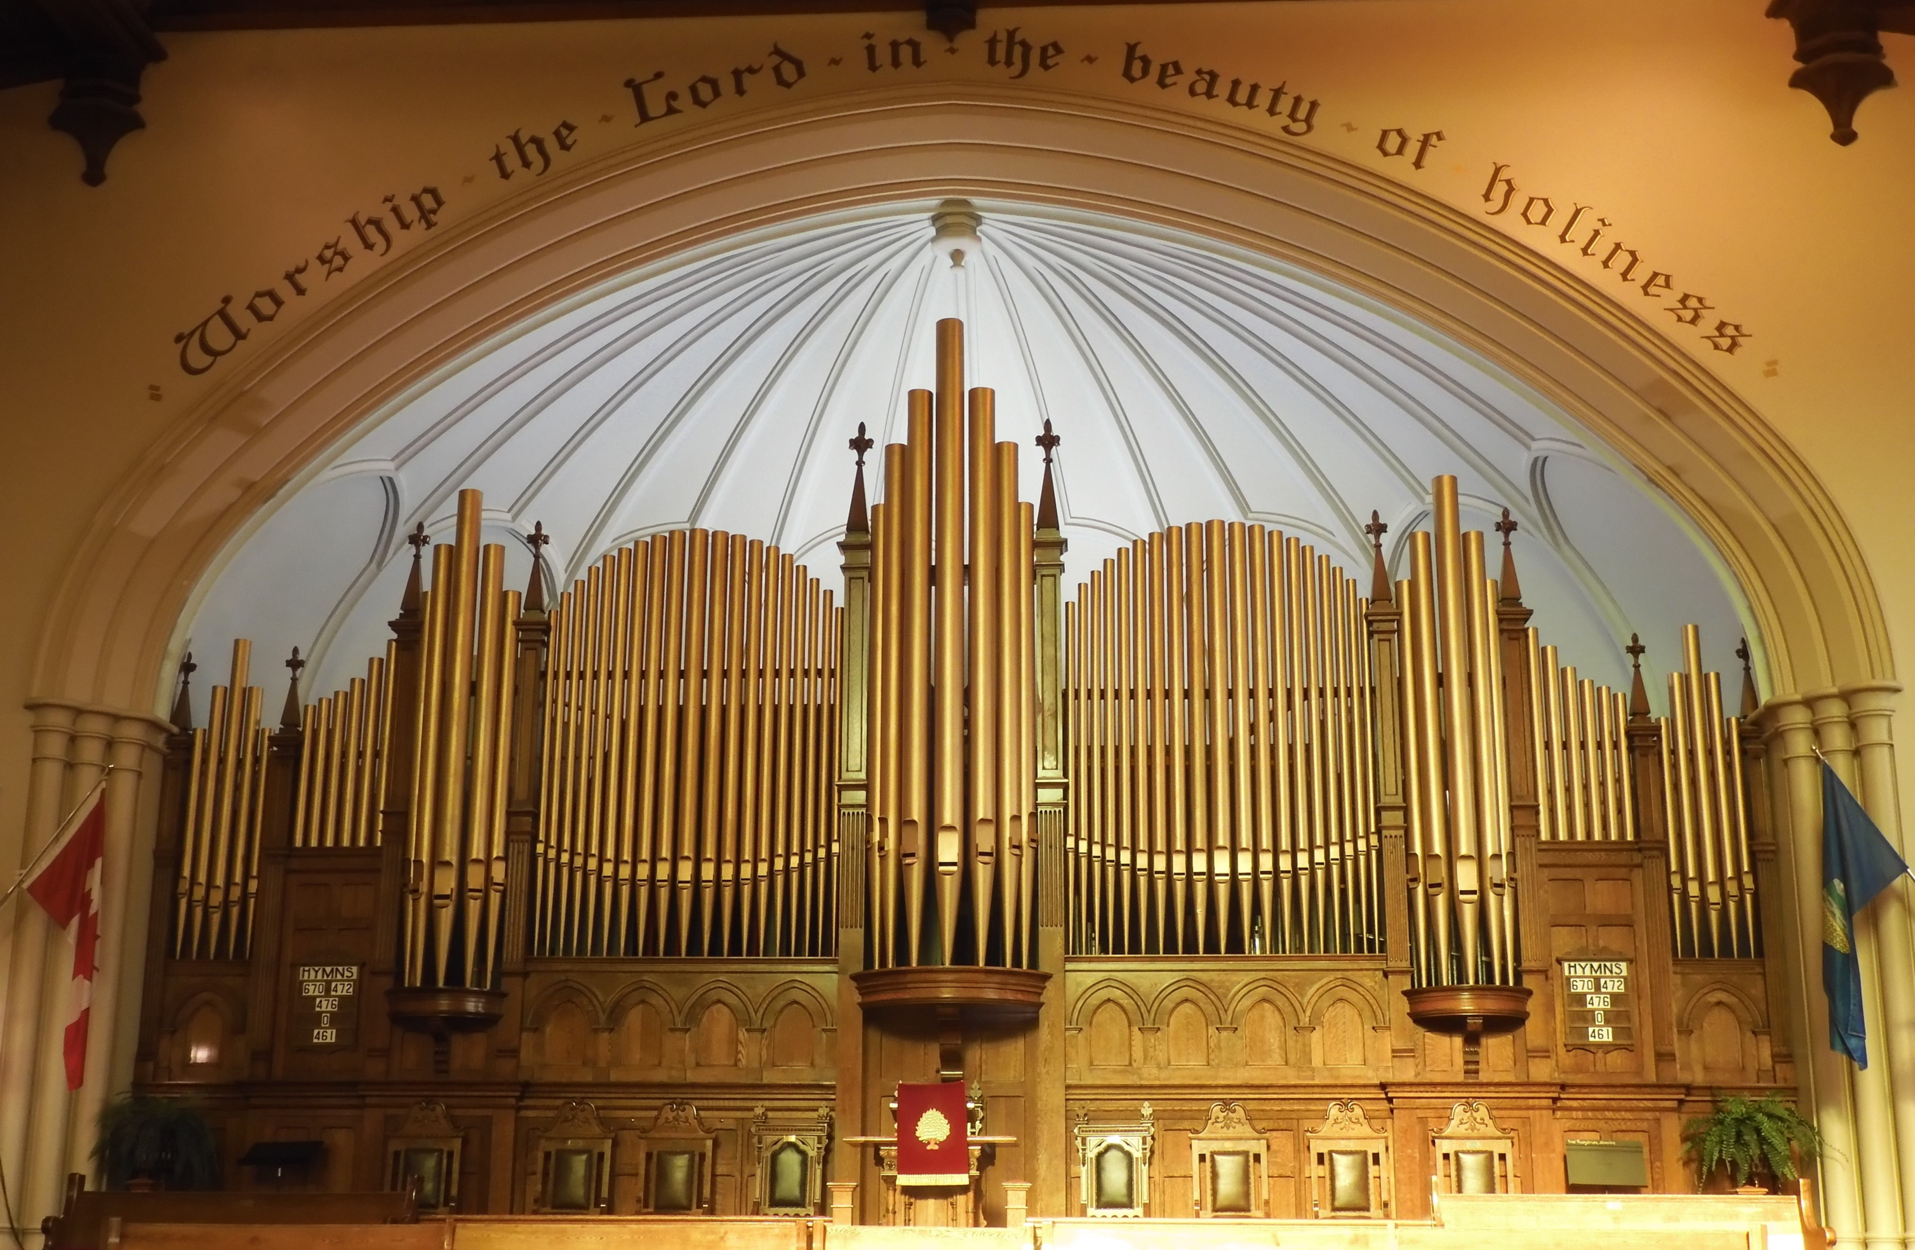
Upon entering First Presbyterian Church in downtown Edmonton on 105 Street, the first feature to be noted is the huge Casavant organ, an instrument with 2,332 pipes. The tour began with a mini-concert that demonstrated the splendid sound of the organ, enlarged for the third time in 2007. The church, dating from 1912, is one of the biggest in Edmonton, the third First Presbyterian Church, starting with the first one that seated 200 people. The church can seat a thousand people and the church tower is 34 meters high, and. Features in the church include a six-room museum.

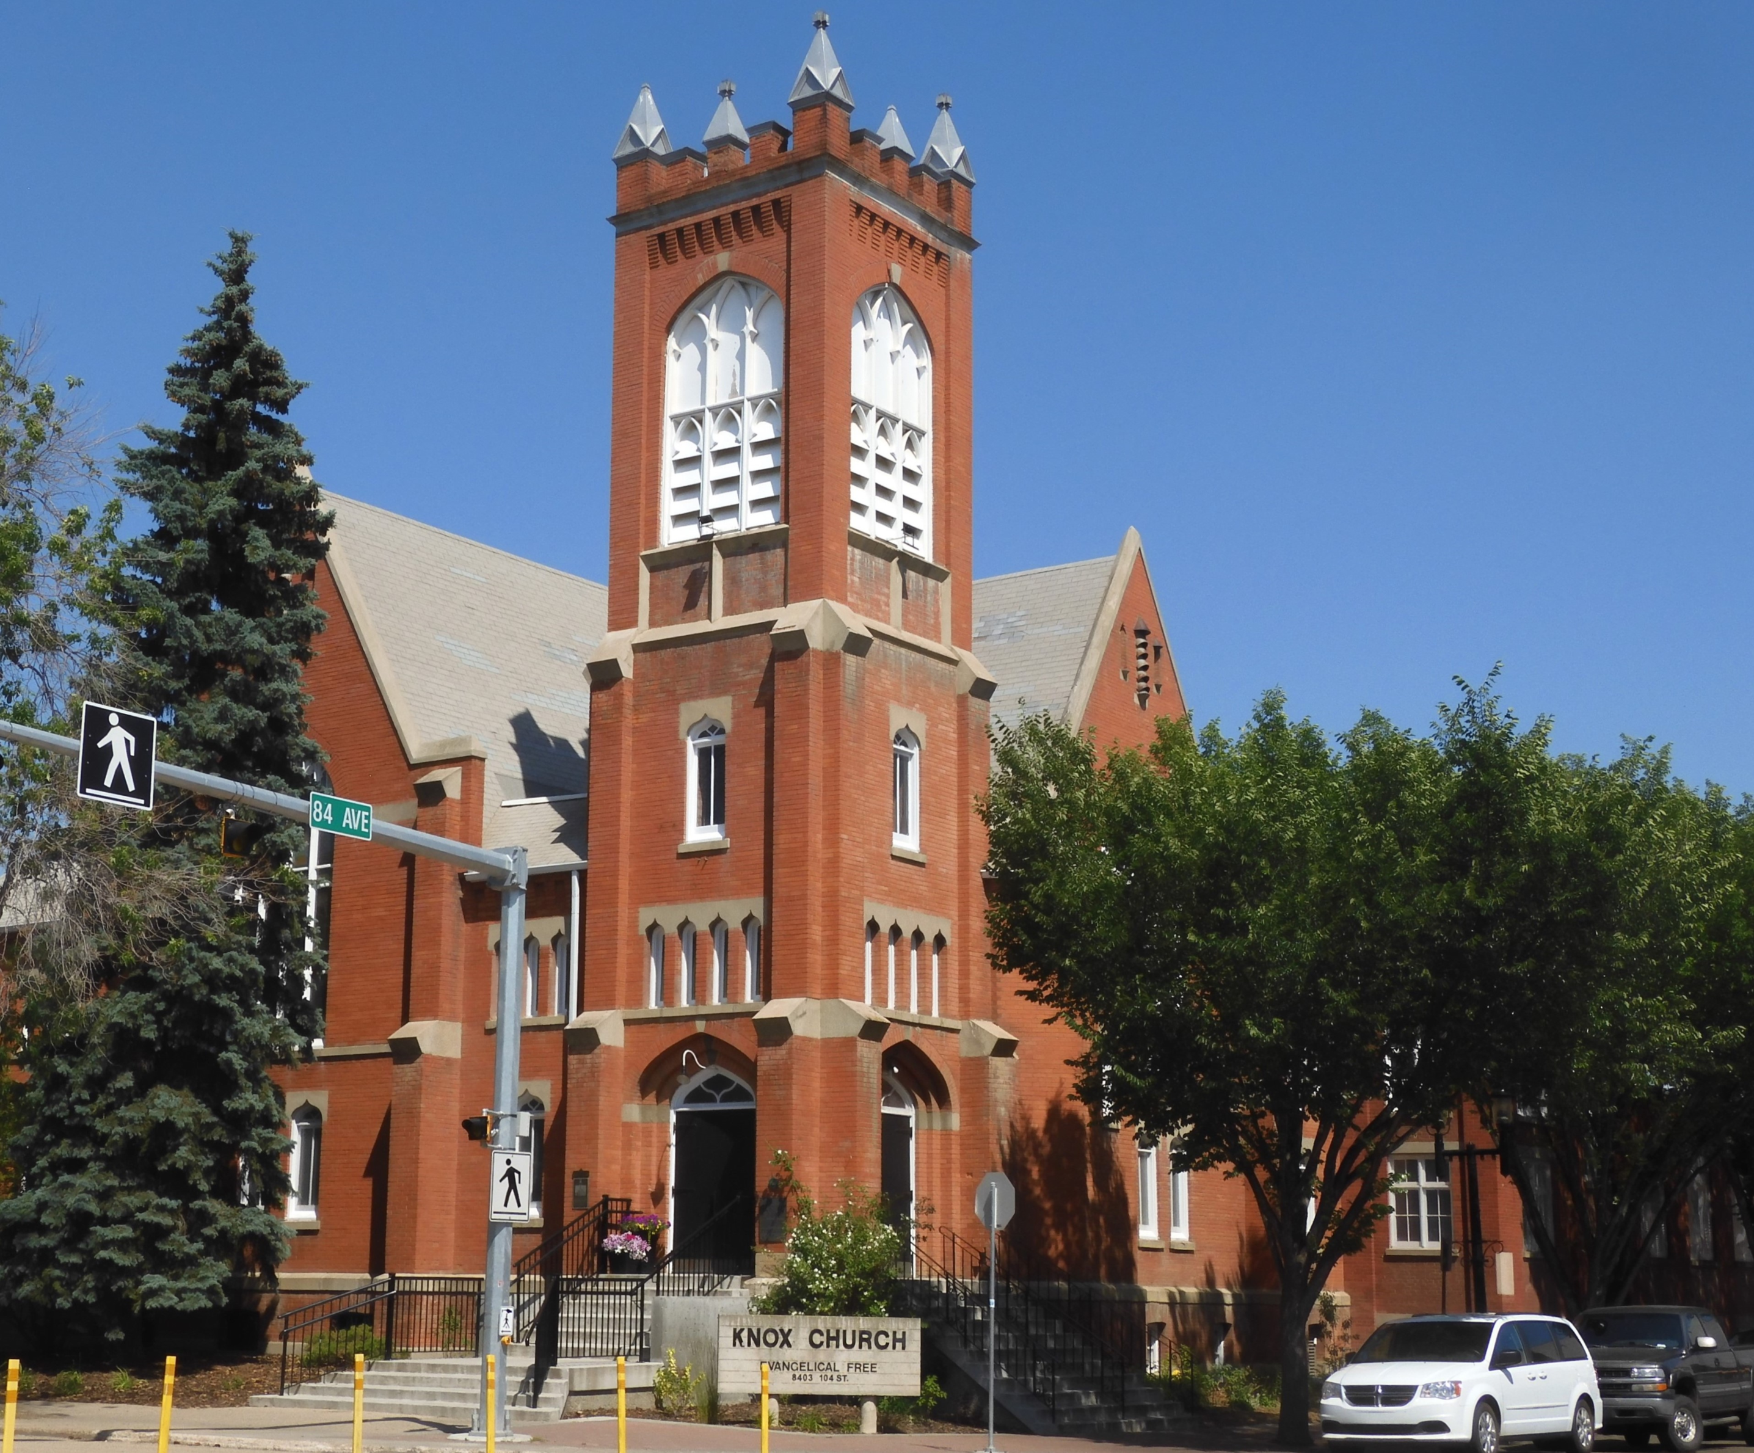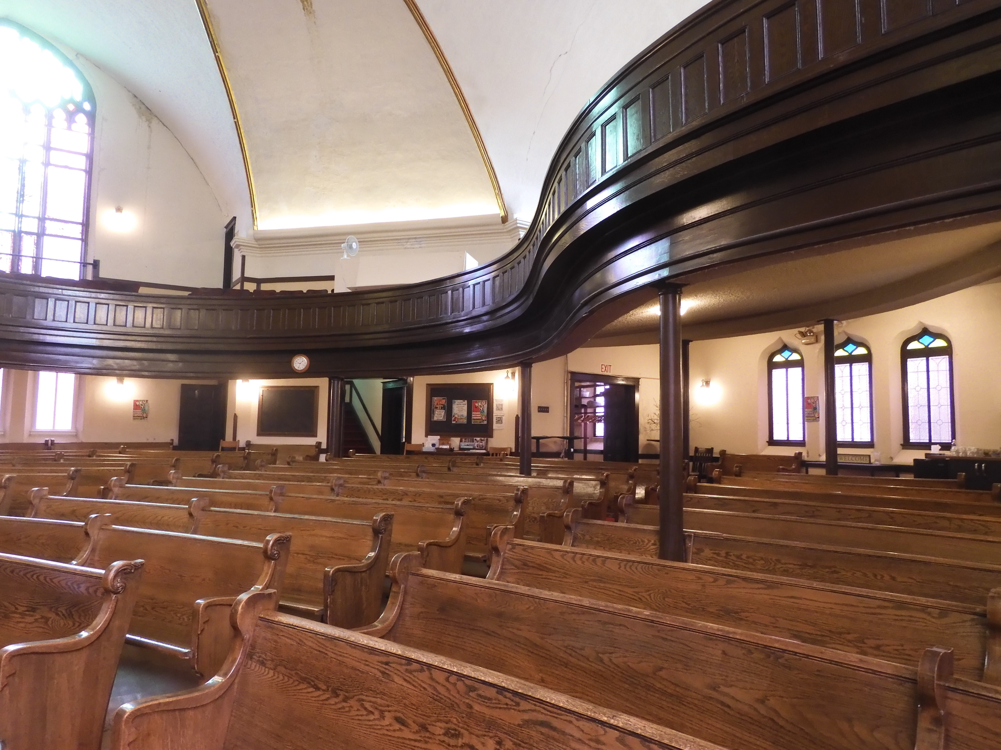
Knox Church on 104 Street in the Old Strathcona district is another Edmonton pioneer building, which began use in 1907 as a Presbyterian Church, then served later as a United Church starting in 1925. It was sold in 1972 to become an Evangelical Church. The pews on the main floor are original from 1907 and the church seats 600 people. The tour of the church was accompanied by music from the pipe organ. Like many of the historic buildings of the same vintage built in the area when Strathcona was a separate city, Knox Church is of brick construction.
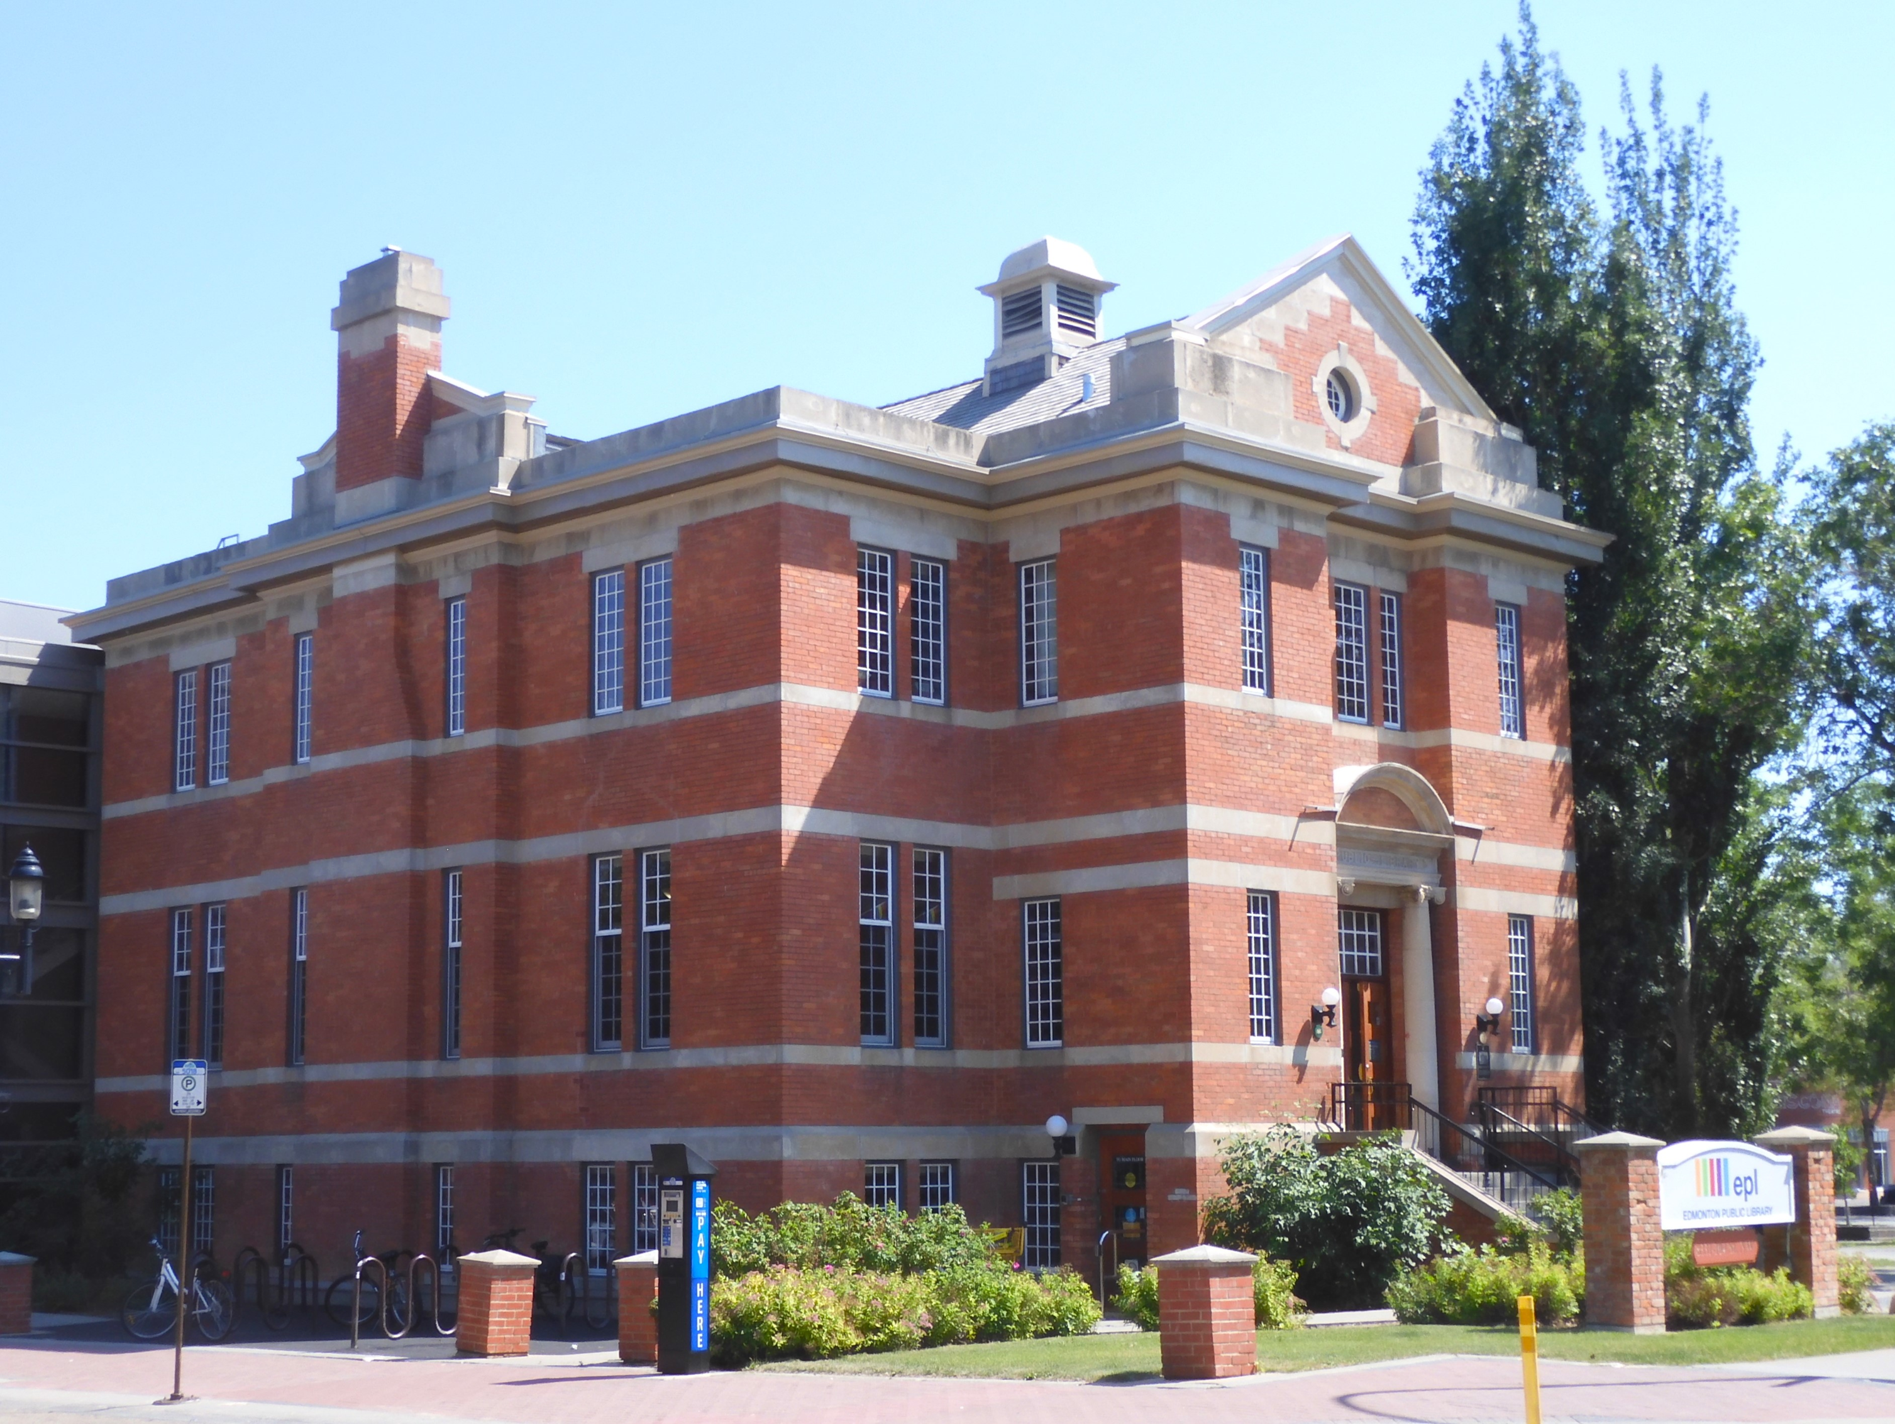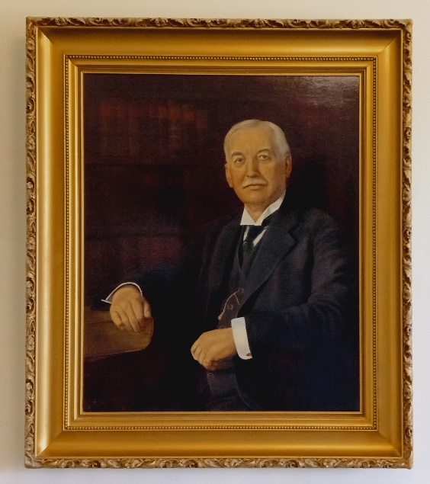
At the same corner of 84th Avenue and 104 Street, proudly stands another brick building, the Strathcona Branch of Edmonton Public Library, serving readers and book borrowers since it opened in 1911. The Historic Festival provided opportunity for visitors to take a self-directed tour to see books on the main floor, a children’s and a magazine section in the lower level and the program room on the second floor, which is used for various activities. At the top of the stairway hangs a portrait by William Johnstone of L.T. Barclay, a chairman of the library board in its early days.
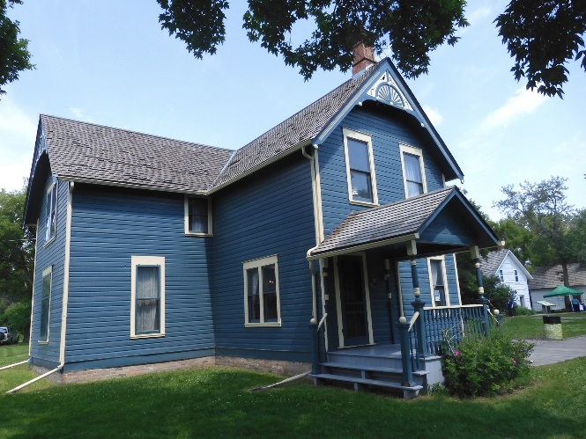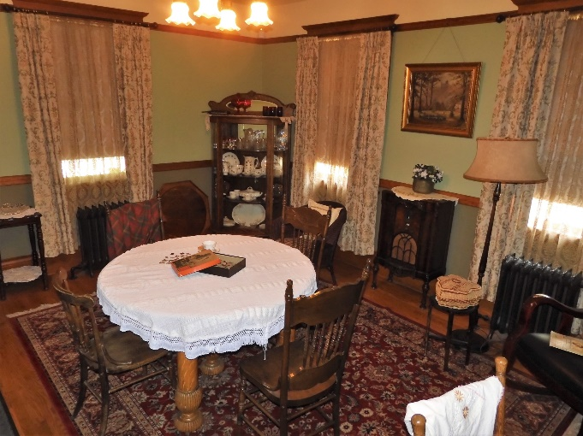
The John Walter Museum, open Sundays from 1-4 pm, is located in Kinsmen Park and consists of three houses built by Edmonton pioneer, John Walter. The previous two houses were built of logs. This is the newest, built 125 years ago and occupied by John’s wife, Annie, until 1942. The house is restored to its state in 1920, the year John died.

